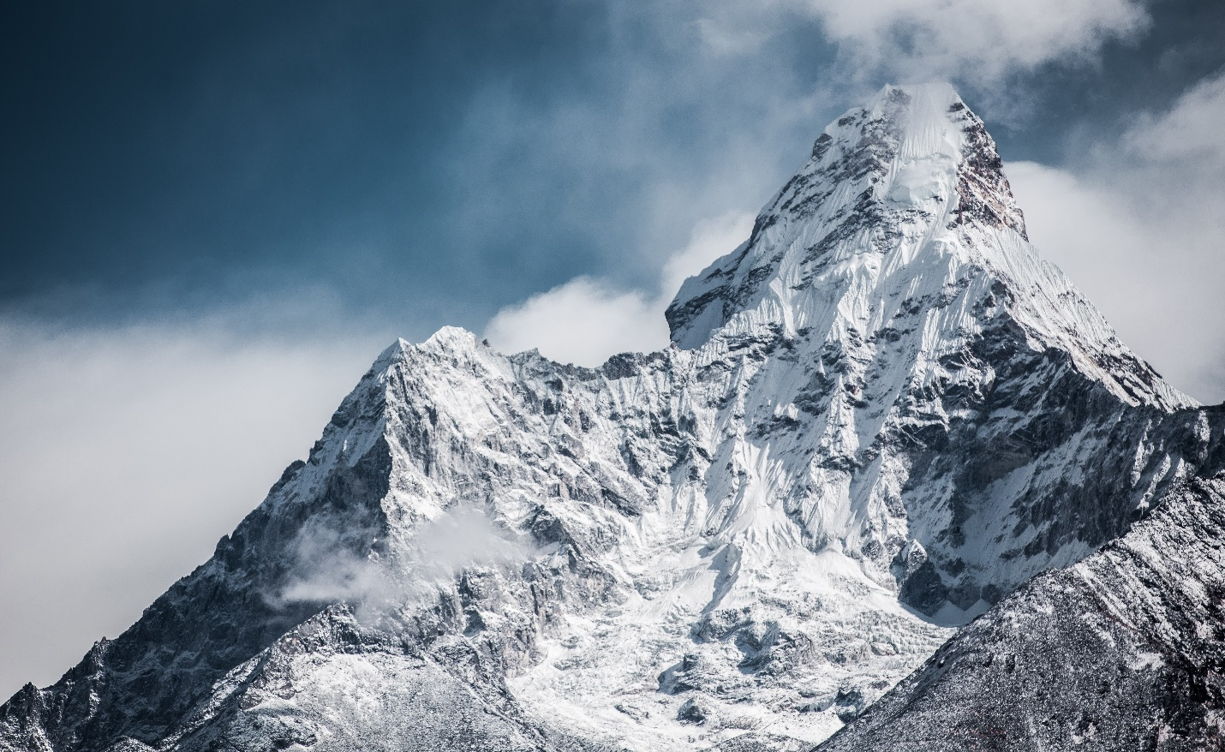

**Mount Everest**

Mount Everest is the world's highest peak, standing at 29,032 feet (8,848 meters) above sea level.

**History**

Mount Everest, Earth's highest peak at 29,032 feet (8,848 meters), was first summited by Sir Edmund Hillary and Tenzing Norgay on May 29, 1953.